
SHIRE HIGHLANDS EDUCATION DIVISION
2026 MALAWI SCHOOL CERTIFICATE OF EDUCATION MOCK EXAMINATION

BIOLOGY
Subject Number: M022/II
Wednesday, 18th March Time Allowed: 1hr 30min sessions
10:00am onwards

PAPER II
(40marks)

Practical
Instructions
Question Number | Tick if answered | Do not write in these  columns
1

2

3

4

- This paper contains 6 printed pages. Please check.
- This paper contains two sections; A and B. Section A has two descriptive questions and section B has two questions on experiment.
- Before beginning, fill in your Name and Examination Number at the top of each page of the question paper.
- Answer all the four questions in the spaces provided on the question paper. The maximum number of marks for each answer
is indicated against each question. A pencil should be used for all drawings
- At the end of the examination, hand in your paper to the invigilator.
- In the table provided on this page, tick against the number of the question you have answered

Turn Over

SECTION A: (20 marks)

- Describe an investigation that could be conducted to determine the effects of using a large sample and a small sample in estimation of population. In your answer, include procedure, expected results and conclusion.
_______________________________________________________________________________________________________________________________________________________________________________________________________________________________________________________________________________________________________________________________________________________________________________________________________________________________________________________________________________________________________________________________________________________________________________________________________________________________________________________________________________________________________________________________________________________________________________________________________________________________________________________________________________________________________________________________________________________________________________________________________________________________________________________________________________________________________________________________________________________________________________________________________________________________________________________________________________________________________________________________________________________________________________________________________________________________________________________________________________________________________________________________________________________________________________________________________________________________________________________________________________________________________________________________________________________________________________________________________________________________________________________________________________________________________________________________________________________________________________________( 10 marks)
- Describe an experiment that could be carried out to investigate effects of particle size on enzyme activity. Your answer should include procedure, expected results and conclusion.
_______________________________________________________________________________________________________________________________________________________________________________________________________________________________________________________________________________________________________________________________________________________________________________________________________________________________________________________________________________________________________________________________________________________________________________________________________________________________________________________________________________________________________________________________________________________________________________________________________________________________________________________________________________________________________________________________________________________________________________________________________________________________________________________________________________________________________________________________________________________________________________________________________________________________________________________________________________________________________________________________________________________________________________________________________________________________________________________________________________________________________________________________________________________________________________________________________________________________________________________________________________________________________________________________________________________________________________________________________________________________________________________________________________________________________________________________________________________________________________________________________________________________________________________________________________________________________________________( 10 marks)
SECTION B (20 marks)
- You are provided with 12 leaves of different lengths.

  - Measure each leaf and record in the table 1.
Table 1
Length of leaf (mm) | 0 – 70 | 71-90 | 91-170 | 171-220
Number of leaf (Frequency)
(4 marks)
b.
    - What type of variation is represented by this data?
___________________________________________________
(1 mark)
    - Give reason for your answer in b (i) above.
____________________________________________________________
____________________________________________________________
(1 mark)
iii. Find the modal length of the leaves.
______________________________________________________________
_____________________________________________________________
(1 mark)

c. On the graph paper provided construct a bar chart of frequency against length
interval.
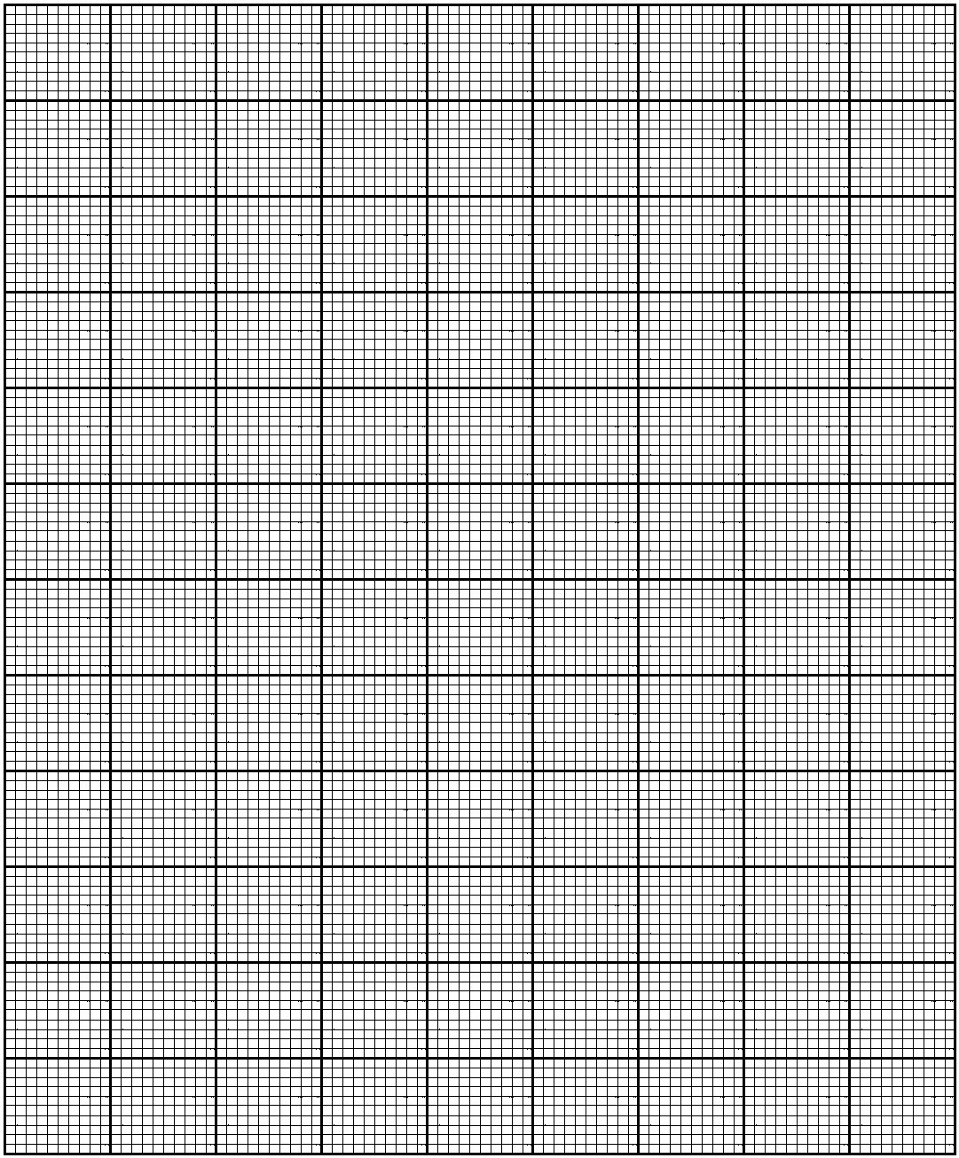
(3 marks)

- You are provided with the following materials.
- specimen Q
- razor blade or scalpel
- 30cm ruler
Cut specimen Q longitudinally.
  - Draw one portion and label any three parts.

(4 marks)
  - (i) Measure the longest axis of the portion drawn in mm.
___________________________________________________(1 mark)

(ii) Calculate the magnification of your drawing and show your work.

(2 marks)

NB: This paper contains 6 printed pages.
END OF QUESTION PAPER

